**irFFB2022 Guide**

Tom Hogue August 2022

**Acknowledgements**

I had come across irFFB in the iRacing Forums and as a result found irFFB code at http://github/nlp80. In the forums, I think he goes by Nick, but wanted to say thank you for your original work. This release is an extension to that work and hopefully we can keep this work alive by this update. Fuzzwah on github has worked hard to update and expand the cars that could use the understeer features. Others have contributed to irFFB as well as many that participated in forum discussions on it.

In those forums, there is a valid debate on whether or not using telemetry to enhance the FFB signal provides any value. I myself have gone back and forth on this subject and even stopped using irFFB after I got my Accuforce Direct Drive wheel. I will tell you that when I ran a Logitech G29, it was a world of difference and would not run without it. I have been running the Nascar Cup NextGen cars and like others was fighting the snap spin with those cars. It was at Martinsville that for some reason I had decided to test irFFB again and was surprised to find that I was getting an early feel for a snap loose condition in time for me to correct for it. Taking irFFB one step further to retest on a road course with the F3, I did not feel as much benefit for the oversteer condition, but rather for the understeer condition. Will you find a benefit? I am not sure, but it is worth a try.

**Introduction**

This document assumes the reader has already installed irFFB. If not, here is a great video on how to install irFFB. Once installed, simply copy irFFB2022 on your hard drive and launch to run.

Boomer Studios Racing

<https://www.youtube.com/watch?v=lcHAX-OS58A>

irFFB2022 is an update to irFFB that is found on the nlp80/irffb github repository that was last updated sometime in 2020. The irFFB2022 version keeps the core internals as in the original version of irFFB, but simplifies the configuration and controls of irFFB so that users can optimize their settings for their car and track. The key objective was to make irFFB easy to understand and easy to use. As a result, you will find it much easier to optimize your FFB experience in iRacing and achieve most consistent lap times over a longer period of time. For those NextGen Cup racers, you may even find yourself recovering from those dreaded snap spins. It was those snap spins that got me to come back and take a new look at irFFB.

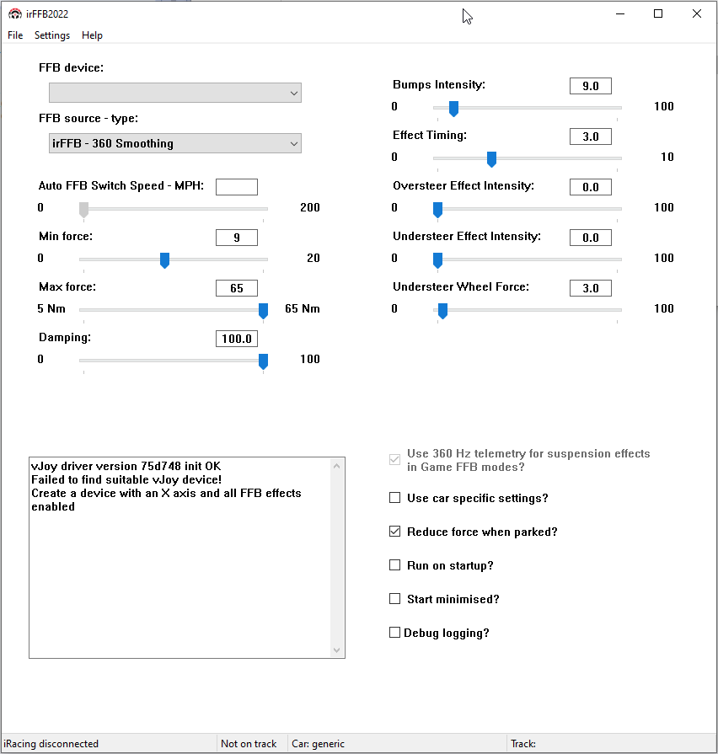

* Easy to Understand Modes
* Automatic -360 Smoothing Mode for a blend of Low Latency and Telemetry Enhancements
* Previous “Offsets” were modified and presented as “Effect Timings” in a simple single control slider
* SoP renamed to Oversteer to make it easier to understand
* Understeer enabled for all cars and easily configured with a slider
* Car and Track combinations are saved together to reduce configure a car for a track

**Modes**

The naming of the modes has been changed so that it is easier to understand how they differ. There are two primary modes of operation:

Game provided FFB signal to wheel with 360Hz or 720hz Smoothing

irFFB provided FFB signal to wheel with 360Hz Smoothing

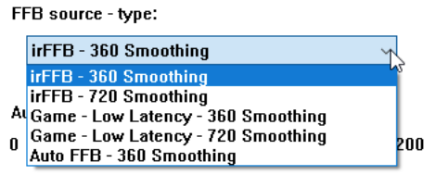

Just as in the original irFFB, the different FFB modes have different latencies (delay) in the FFB signal to the wheel. These latencies are the same as they were in the original irFFB. Both modes can have telemetry enhancements and smoothing applied to those signals.

Telemetry enhancements gives us a feel of how the car is handling on the track.

Smoothing gets rid of the “Clunky” feeling in the wheel.

The game puts out a 60Hz FFB signal and just like how we see a flicker in fluorescent light bulbs, our hands can feel that slow rate in the wheel. All wheel manufactures will smooth out that signal and irFFB does that as well. There is a 360Hz and 720Hz smoothing options and they don’t add significant latency, so choose 720 smoothing as often as possible.

Telemetry enhancements gives us incredible feel of how the car is handling on the track by blending in steering wheel torque, yaw, and suspension forces to the FFB signal. This allows us to feel the understeer and oversteer conditions earlier in our turns than with the Game FFB signal alone, but it comes at a latency cost.

Game FFB Latency = 4ms for game FFB and 15ms later for enhancements

irFFB FFB Latency = 29ms

To help understand what 4ms, 15ms and 29ms updates to our wheels in a game means the car, refer to the chart of speed vs FFB updates. Using the chart, you can find how fast your car is traveling and then see the distance the car travels while we are waiting for an FFB update. If the update comes too late, then we are turning or reacting too late. If we look at 100mph, we see that Game FFB Modes gives an initial update within 5.87 feet, then another at 22ft. In the irFFB FFB Modes, we travel 42.53 feet before we get an update but then we get signal smoothing between updates. Use the chart to help you decide on which FFB mode based on the track and speeds you will be racing. Most of the time, road courses would find benefit from the enhanced telemetry because they are traveling at slower speeds in the corners. Tracks like Daytona would need the lowest latency options because the distanced traveled between updates reach up to 85feet with the 29ms latency. Do you have to choose? This is where the new Auto – 360 Smoothing Modes comes into play.

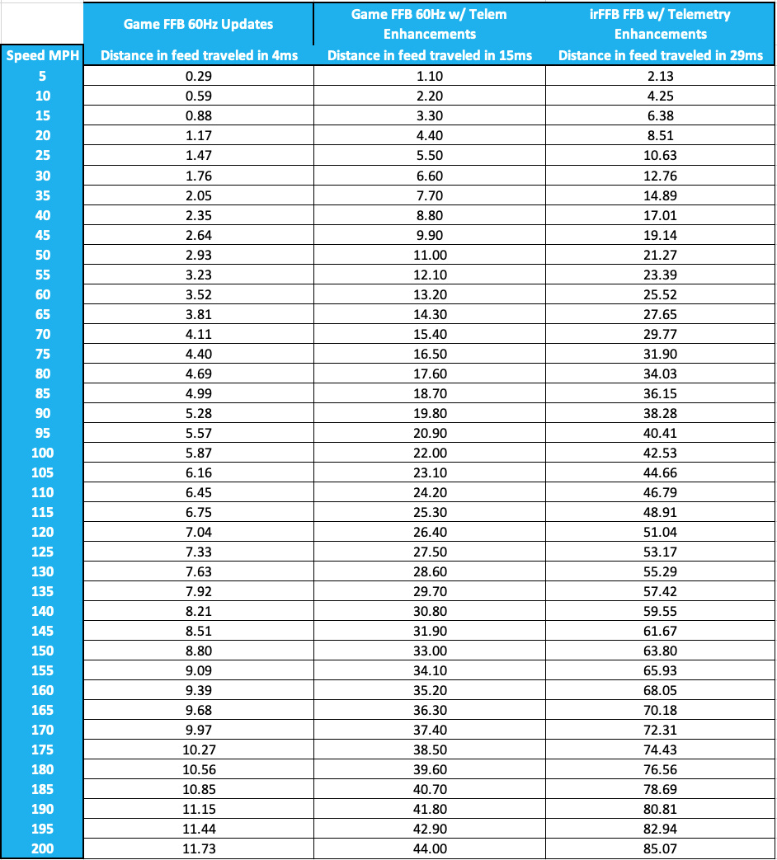

**irFFB – 360 and 720 Smoothing Modes**

These two modes are the same as in previous versions, but renamed for to make it easier to understand how they work. They both ignore the Game FFB signal that is sent to the Vjoy driver and generate an enhanced FFB signal that incorporates yaw, steering wheel torque and suspension forces. They both use 360Hz telemetry which is why the 29ms delay. The 360 mode is then smoothed at a 360Hz rate while the 720 is smoothed at a 720Hz rate. The 720 mode is going to be smoother than the 360Hz. This difference can be felt more when the Max force is set to a stronger setting as well as if Bumps is at a high setting.

Note: Always have the game set to “Game FFB”.

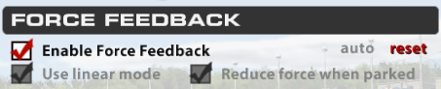

**Game – Low Latency – 360 and 720 Smoothing Modes**

Again, there is no change here other than a name change. These two modes were the “Direct” modes in the previous version. These modes allow the option to use the 360Hz Telemetry with the “Use 360Hz telemetry for suspension effects in Game FFB modes.” Note that there are 60Hz telemetry enhancements in the Game FFB modes even if the 360Hz Telemetry option is not checked. Again, all modes use telemetry enhancements of either 60Hz or 360Hz telemetry. These modes are best used in the high-speed tracks as discussed above.

**Auto – 360 Smoothing FFB Mode**

This is where the new mode, called Auto FFB – 360 Smoothing comes into play. This new mode automatically switches between the Game irFFB FFB signal with low latency and the irFFB2022 FFB signal and provides a control to set the speed for the automatic switch over. This gives you the enhancements through the corners and then low latency at high speeds. High speed ovals such as Daytona would NOT be a good fit as you would want low latency that the continuous high speeds. Grand Prix races with tight corners would be a great fit for the irFFB FFB signals. Auto -360 Mode gives you the best of both worlds.

To use:

Enable the Auto - 360 Smoothing.

Adjust the Auto Switch Speed in MPH to the speed in your corners. Adjust just slightly above your max speed in the corners. You will probably fill a bump in the wheel as the modes switch back and forth. You can minimize that bump by adjusting your Max force setting as the two modes have a slight difference in wheel torque they send to the wheel.

**Min Force**

This feature did not change from previous versions. If you are using <2NM wheels, then you will most likely need some low value on this setting. Don’t go too high as you are consuming your limited Wheel Torque range with this feature.

**Max Force**

This feature did not change from previous versions as it still runs opposite in range of the game. Lower number is a stronger wheel and a higher number is a weaker wheel. There is a good reason for this but that discussion is out of scope for this document. Just remember that as you set this value that setting it too high can mask your other features like Bumps, Oversteer and Understeer. Making the wheel feel too strong hides the other features, setting it too low and you can’t feel the track. You will find that if you are not seeing any affect in the Understeer Wheel Force slider settings that you may need to make the wheel feel lighter by increasing the Max Force setting.

**Damping**

This feature did not change and honestly in future versions, it should probably be removed. Damping should be done at the wheel firmware level. Recommend a 0 setting.

**Bumps**

This feature did not change from previous versions. Turning the Bumps up too high will make the wheel feel “notchy” but too little you won’t feel where the bumps are which are necessary to feel when doing car setups.

**Effect Timing**

The Effect Timing affects the timing through the turn when you should feel the effects start. It is not easy to feel the effects of this setting as it is based on slip angles entering the turn. We tend to vary our slip angles entering turns, but more consistent drivers may find a noticeable difference. If the setting is too high (larger number) then the effects will be too late to be useful. I suggest starting at 3.

**Oversteer and Understeer Effect Intensity**

These features remain the same as previous versions. Think of these as volume controls for the two effects. Just like the Max force and Wheel force settings, these two can mask each other if they are set incorrectly. Start at 50 on each of them and tune as appropriate based on the track.

**Understeer Wheel Force**

Understeer Wheel Force is a control that allows you to adjust how soft the wheel force will feel like when you are in an understeer condition (aka pushing through the corner towards the wall). If the setting is too low, then you won’t get enough toque to the wheels to turn, but if it is too high then you won’t feel the push condition. Finding an optimum setting allows us to feel exactly when we are pushing and losing speed. Start at a higher value and then keep lowering until you feel the wheel get soft as you try to turn. If you find that the wheel is not getting soft, then that indicates your Max Force setting is set too strong (low on the slider).

**Saving Configurations**

IRFFB2022 saves your car AND track configurations in a new iRB2022.ini file in your Documents folder. As you go between cars and tracks you will see each combination needs it’s own configuration to optimize your FFB. You will find that you will spend less time configuring irFFB with this approach.

Suggestions for Car and Track IRFFB Tuning

When you get in a car at a new track for the first time with IRFFB2022 and bring the irFFB2022 up in a window you will find that the initial “Generic” settings that loaded up in irFFB2022 will be very close to being able to race with. Here are some tips:

1. Select Operating Mode
2. Adjust Max Force
3. Adjust Understeer Wheel Force
4. Adjust Understeer Effect Intensity
5. Re-adjust Max Force to ensure Understeer Effect Intensity is optimized
6. Adjust Oversteer Effect Intensity to make sure oversteer effects are not masked
7. If using Auto – 360, adjust Auto FFB Switch Speed for max speed in corners.
8. Adjust Bumps to feel track but not so high wheel becomes notchy
9. ENSURE DEBUG IS NOT SELECTED.
10. Run on Minimized is not recommended
11. Select Use 360 telemetry if you are using Game FFB modes

When tuning your IRFFB2022, keep in mind that all of the settings are interrelated. For example, if you have the Max Force setting too strong, then you will not be able to feel the oversteer or understeer effects. The same goes for the oversteer and understeer effects masking each other out. If you are finding you are not feeling one of the effects, then look to see if you have another effect too high. Just like if you have the bass turned up too loud on a music player, you won’t be able to hear the high ranges of the music. Steering Wheels and FFB operate in the same fashion.